Lab 8

Introduction

The objective of this laboratory experiment is to become familiar with applications of MOS and Bipolar transistors as small-signal amplifiers. Both BJTs and MOSFETs are semiconductor devices that can be used in both analog and digital applications. In this lab, MOS transistors will come from the XEDU1000B MOSFET array. The BJT that will be used is the PN2222 .

**Part 1 Voltage Controlled Amplifier**

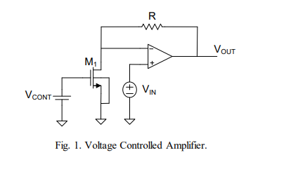

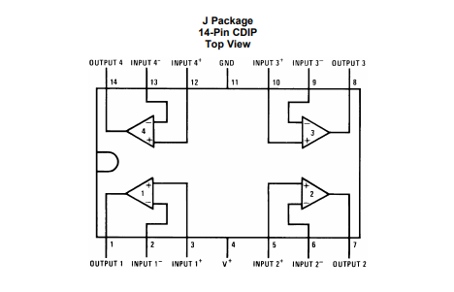

**determine R so that the voltage gain is 30 with VCONT = 2.5V**

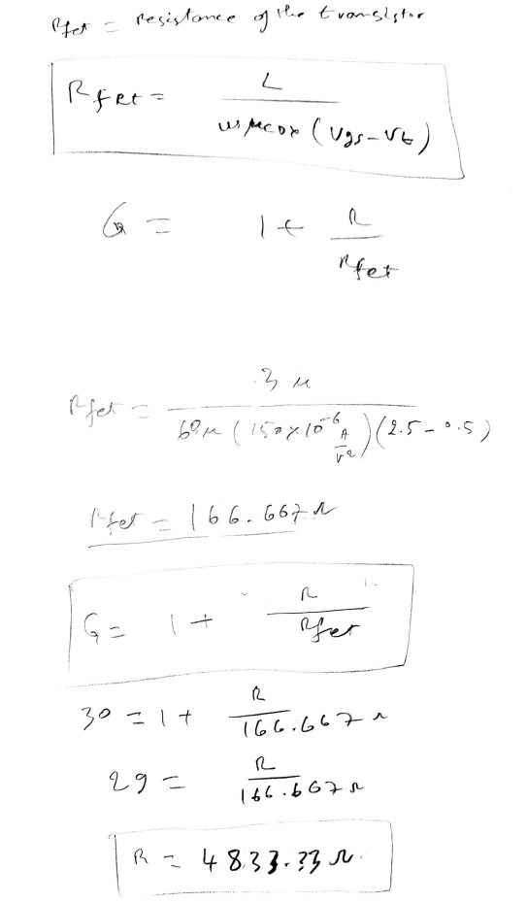

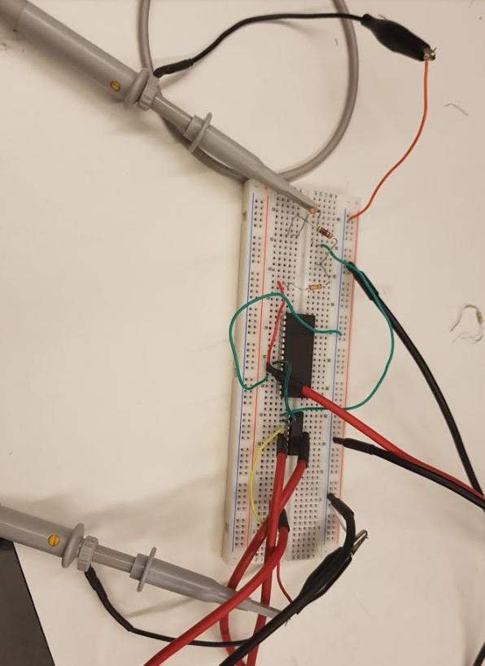

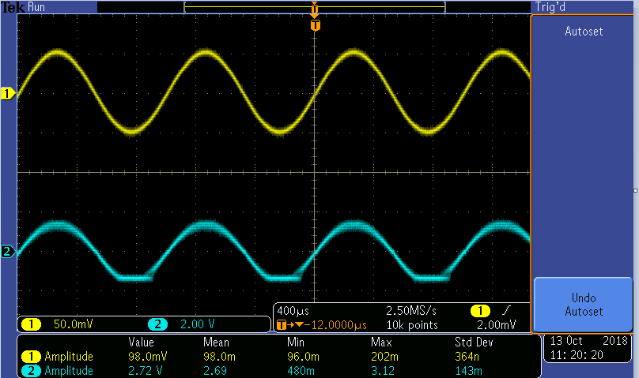

G= Vout/vin = 2.72V/(0.098v) = 27.755

**What does VCONT need to be changed to for a gain of 10?**

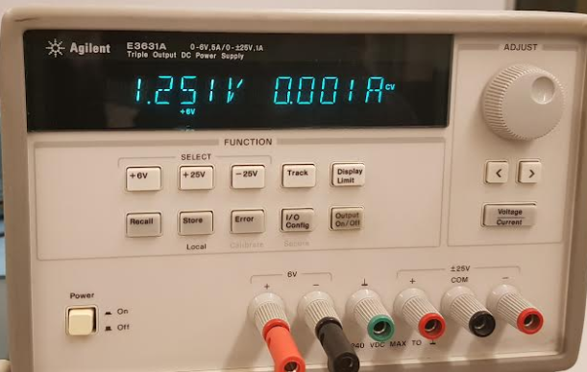

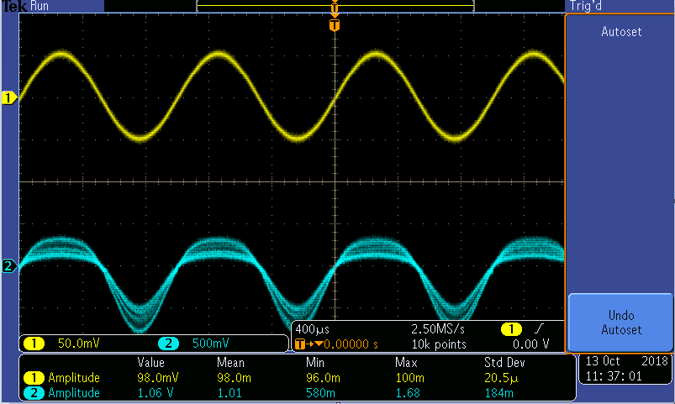

**G = 1.06/0.98 =10.81**

at the voltage VconT about **1.251V,** the gain is about 10.81.

**Part 2 A Nonlinear Application**

In this part of the lab, I am going to predict the relationship between VOUT and VIN for − 2𝑉 < 𝑉𝐼𝑁 < 2𝑉 and verify experimentally. In addition, I am going to predict the output if the input is a 1KHz sinusoidal waveform of 4V 0-p value and experimentally verify

